https://www.qschina.cn/university-rankings/world-university-rankings/2021

https://www.usnews.com/education/best-global-universities/rankings

https://www.timeshighereducation.com/world-university-rankings/2021/world-ranking#!/page/0/length/25/sort_by/rank/sort_order/asc/cols/stats

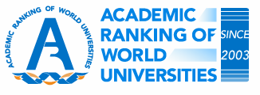
http://www.shanghairanking.com/ARWU2020.html

