QS World University Rankings® 2019:
https://www.topuniversities.com/university-rankings/world-university-rankings/2019

Best Global Universities Rankings (2019)
https://www.usnews.com/education/best-global-universities/rankings

The Times Higher Education World University Rankings 2019
https://www.timeshighereducation.com/world-university-rankings/2019/world-ranking#!/page/0/length/25/sort_by/rank/sort_order/asc/cols/stats

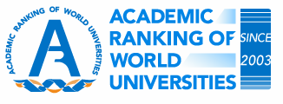Academic Ranking of World Universities 2018
http://www.shanghairanking.com/ARWU2018.html

